ANYA TURNER & ROBERT GRUSECKI
MID-CENTURY MODERN
CD | Digital
Talkin' Broadway – Rob Lester
August 21, 2023
Quite a few years ago, while shopping, I ran across the first two albums by Anya Turner and Robert Grusecki and bought them on instinct. I didn't regret it. Back then they were billed more briefly as just Anya & Robert. Listen to this married couple perform the songs they write on any of their nine recordings and the down-to-earth, direct-from-the heart, warm personalities projected and I bet you'll feel you can be on that first-name basis with them.
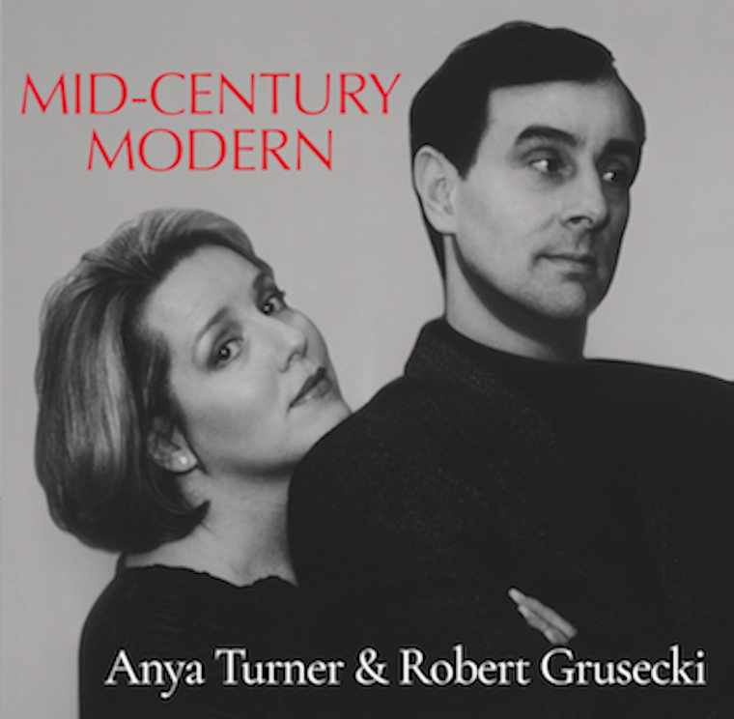
Radiating sincerity, with some humor as the spice in the sweetness, Mid-Century Modern is a prime example of the approachable, direct M.O. that she (vocals) and he (piano and some vocals for duets) specialize in. Their songs here are a mix of sharp observations on modern life, nostalgia, simple pleasures, unabashed affection, melancholy, and what feel like soothing lullabies for adults. There are only ten tracks on Mid-Century Modern, but some items are rewardingly deep or breathtakingly touching. Their lean, less-is-more way of writing and performing is classy and smart. Sometimes the humor is more modest than LOL, but it can be pointed and sly. Restraint can reap rewards.
Let's look at a few excerpts from the highlights:
"Watch the seasons roll by/ Like the clouds in the sky/ Never questioning why/ It's enough for me/ Life is quiet and sweet/ Kick a can down the street..." is a serene picture of life in a "Small Town."
"Ev'rything is going well/ As far as anyone can tell/ But ev'rything is shot to hell" and "Splish, splash/ Life's a dash/ To flim, flam and grab the cash/ And turn out tons of trash..." are revelations in "Our Little Secret."
"They prowl up and down/ The streets of the town/ And they sniff and they snort and chew/ They howl and they hiss/ And they fawn and they kiss..." describes the members of a "Weird Little Club" they disdain.
Anya Turner and Robert Grusecki have the aura of honesty and lived-in wisdom whether they're facing and embracing heavy emotions and realities or breezing through a light-hearted tune. Physical copies of this recording can be ordered through AnyaRobertMusic.com, which also has the lyrics for these songs.

